TERMWORK 3

NAME: name

USN: 2GI20CSXXX

DATE: 02/12/2022

When file is locked, another process cannot access that file

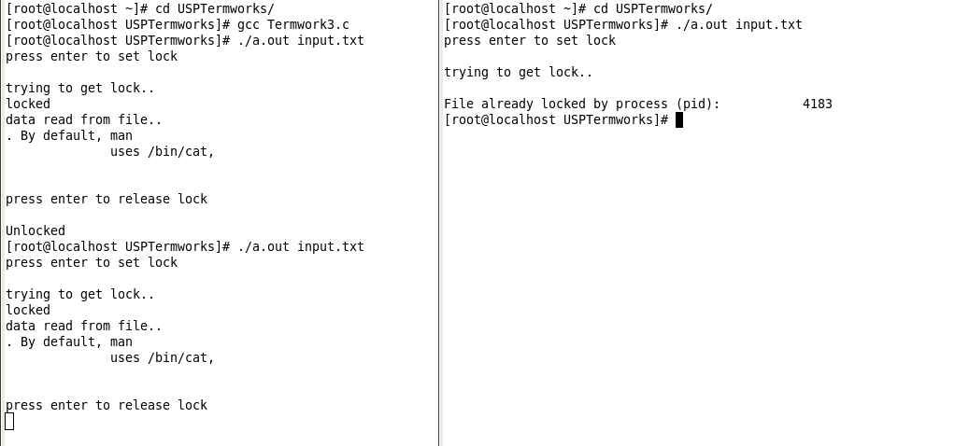

When file is unlocked, another process can access the file

